Mexico City, July 13th, 2017

THESE COULD BE THE MEXICAN FACES FOR FORMULA 1® FUTURE

The FORMULA 1 GRAN PREMIO DE MÉXICO™ keeps up with its commitment to promote those good actions made in Mexico for UNAM Motorsports team supporting.

- Members of the Greatest Study House in our country will travel to Europe, to represent Mexico in Formula Student category competitions for the first time.
- “In FORMULA 1 GRAN PREMIO DE MÉXICO™ we keep up supporting projects that position our country before world’s eyes; promoting young talent in our country makes us feel proud”, said Diego Pérez Palacios, Commercial Director of FORMULA 1 GRAN PREMIO DE MÉXICO™.

The FORMULA 1 GRAN PREMIO DE MÉXICO 2017TM keeps up with its commitment to promote around the world, how well things are done in Mexico, making public our young people’s talent. This time, F1®ESTA’s organizers do it by supporting college team, UNAM Motorsports, comprised by young people from different areas who could represent motor racing future, as national and international level.

On July 13th, students will travel to Europe to become the first Mexican college team competing at Formula Student category– they will visit Italy (from July 19 to 23), Austria (from July 31 to August 3) and Germany (from August 8 to 12).

Formula Student is an educational competition of university level which consists on designing and manufacturing a racing car, for putting it under different inspections and dynamic tests against teams from other universities. Students do a “real” and technical work since they are also evaluated by their report of costs, business plan performance and design plans. So, Formula Student offers to a new generation of young people, the opportunity to get involved in motor racing.

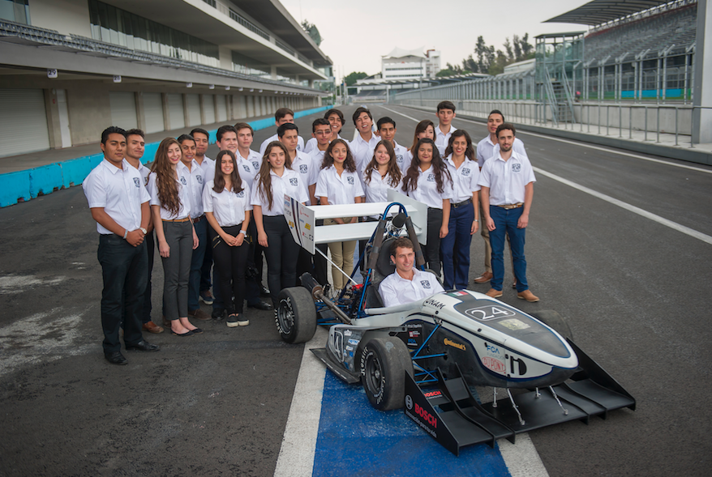

“In FORMULA 1 GRAN PREMIO DE MÉXICO™ we keep up supporting those projects that place our country before world’s eyes. We are committed and proud to promote young talent for the passion for motor racing in our country continues growing”, pointed Diego Pérez Palacios, Commercial Director of FORMULA 1 GRAN PREMIO DE MÉXICO™.

Since, besides being an excellent platform where to knowledge can be executed, on its seven years of existence, UNAM Motorsports has demonstrated to be a professional trampoline for the different students that have comprised the team, prominent amongst them are David Barrera, who worked professionally for team Toro Rosso in the top sport motor racing category; or Jaime Córdoba and Luis Roberto Rivero, who are now working for Toyota Mexico, as District Sales Manager and Product Planning Specialist respectively.

Given this successful precedent, Universidad Autónoma de México’s students– who are currently taking careers such as Industrial Engineering, Mechanics, Electrical-Electronics and Industrial Design, among others – have put all their effort to carry out this innovation project for months, through which they designed and manufactured a racing car with a view to give our country an honorable place.

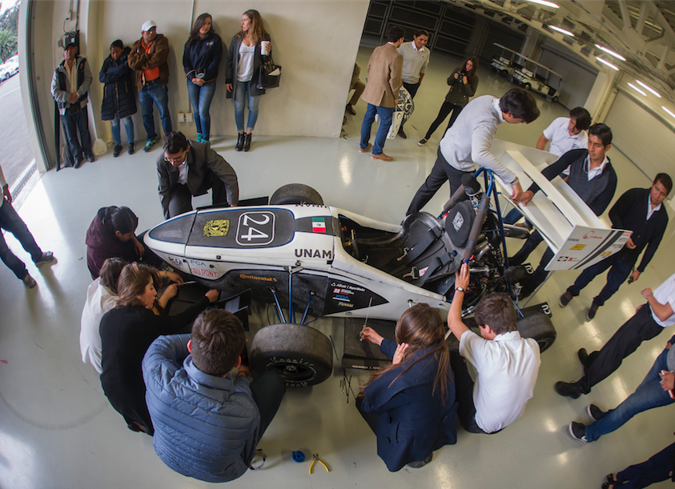

“What team characterizes the most is that we never give up and always find the solution to all the problems we have to face, that’s the bravery which defines us as a team. We are really passionate”, said Daniel Alonso, leader of a team comprised by 33 members. “We are proud to travel abroad and represent Mexico, showing that everything is possible”, added.

However, the participation of UNAM Motorsports in Formula Student is only one way to bring these young fans of motor racing, closer to their dreams: Formula 1®. By the time of their visit, they will compete in two emblematic houses of the top world motor racing category: Spielberg and Hockenheimring circuits – houses of Austria and Germany Grand Prix respectively.

Once again, FORMULA 1 GRAN PREMIO DE MÉXICO™ has clearly stated its search for placing our country through its people’s capacity by joining efforts along with these future agents to projects as UNAM Motorsports, so they become an inspiration for younger generations to come and promoting devotion for motor racing in Mexico.

WWW.MEXICOGP.MX

#MexicoGP #F1ESTA

For more information, follow us on:

@Mexicogp | Mexicogp
MexicoGP | MexicoGP

Press contacts:

CIE  Francisco Velázquez  Press Manager  T. 5201-9089  fvelazquezc@cie.com.mx | MAKKEN  María Torres Farber  Account Director  T. (55) 41600 800 / 900  maria.torres@makken.com.mx

About FORMULA 1 GRAN PREMIO DE MÉXICO™:
The highest category in motor racing has returned to Mexico, after 23 years of absence, pioneer of the greatest sport events in our country. With a term from 2015 to 2019 the renewed Autódromo Hermanos Rodríguez is the perfect stage for the return of the F1ESTA to our country, with a highest world-class level track.
On its first two editions (2015 and 2016), over 375 thousand people attending the race, turned into the second with the biggest number of spectators around the world (after Great Britain).
Until now, FORMULA 1 GRAN PREMIO DE MÉXICO™ has generated over 22 thousand jobs, economic revenue of 1,119 MDD (24,841 million of pesos).
One more year, Mexico will create a world-class position during racing that will take place from October 27th, to October 29th, after having been awarded as the Best Event of the Year by the maximum authorities in world professional motor racing FIA and FOM, during its first two editions.
For further information about FORMULA 1 GRAN PREMIO DE MÉXICO™ go: http://www.mexicogp.mx/

About Formula 1®:
Formula 1® is the most prestigious motor racing competition in the world that has taken the position of the most popular annual sport competition in the planet: In 2016 the championship was witnessed by 400 million of viewers only from over 200 places.
With a long history of glory and racing written since 1950, Formula 1® has been bastion for great drivers, as well as for iconic teams that had led motor racing to being part of collective memory in millions of fans all around the world.
In 2016 FIA Formula One World Championship™ took place from March to November, including 21 races in 21 countries of the five continents. Formula One World Championship Limited is part of Formula 1® and owns the exclusive commercial rights to FIA Formula One World Championship™.
Formula 1® has being raced in Mexico for 17 times, being editions 2015 and 2016 recognized as “The best Grand Prix of the world”. For further information about Formula 1® go to: www.formula1.com

About CIE:
Corporación Interamericana de Entretenimiento, S.A. de C. V. www.cie.com.mx
We are the market leader in outdoor entertainment in Mexico, Colombia and Central America and one of the major players in the entertainment industry in Latin America and across the globe.
CIE offers a variety of world-class entertainment options including concerts, theater productions, and sports and family and cultural events, among others, to meet our market segments’ needs for recreation and entertainment through its unique vertical integration model that provides the only access available to an extensive network of entertainment centers, advertisers, including the main advertising investors in our markets, and partnerships and strategic alliances with experienced global partners.
We operate an amusement and water park in Bogota, Colombia, and manage Centro Banamex in Mexico City, one of the largest convention and exhibition facilities across the globe. We are recognized as the foremost producer and organizer of special and corporate events in Mexico, and we operate one of the most professional contact centers in the Mexican market.
CIE is a public company whose shares and debt securities are listed on the Mexican Stock Exchange.

