INFORMACIÓN PARA LIBERAR EL
21 DE JULIO

Mexico City, July 20th, 2017.

Only 100 days away from Mexico’s #F1ESTA new edition, there are still some limited tickets.

- Just over three months away from FORMULA 1 GRAN PREMIO DE MÉXICO 2017TM, there are still a few tickets available for the best F1®ESTA in the world.

- Seats for tiers 2A and 15 are already sold out, as for the yellow zone and Foro Sol Sur there are still some available tickets.

Today, July 21 we are only 100 days away from letting passion and adrenaline for motor racing to invade again our country through FORMULA 1 GRAN PREMIO DE MÉXICO 2017TM, which is coming back to the Autódromo Hermanos Rodríguez next October 27, 28 and 29.

Just over three months away from the return of the best F1®ESTA in the world, there are still a few tickets to live the experience that has put Mexico on the world’s eyes. In the Foro Sol there are still some seats available in zone Sur (Tier 14), while zone Norte (Tier 15) is totally sold-out. On the other hand, seats at yellow zone (Tiers 09, 10 and 11) are soon to be sold, to be added to the orange zone (Tier 2A) – which is now sold-out as well.

Already on the countdown for the comeback of Formula 1® to Aztec lands, organizers have sped up the arrangements to set everything up and offer again the best show of the world as for fans, as much for category’s directors and drivers; after its last editions – 2015 and 2016 –, the FORMULA 1 GRAN PREMIO DE MÉXICOTM was awarded as Best Event of the Year over the rest of the venues for “the great circus”.

“We are engaged to all assistants to our F1ESTA to keep on showing the world how well things are done in Mexico”, stated Federico González Compeán, CEO of FORMULA 1 GRAN PREMIO DE MÉXICO 2017TM “We are enthusiasts with the arrival of this third edition, for we are working hard to keep up with the level that has distinguished us so far”, added Director.

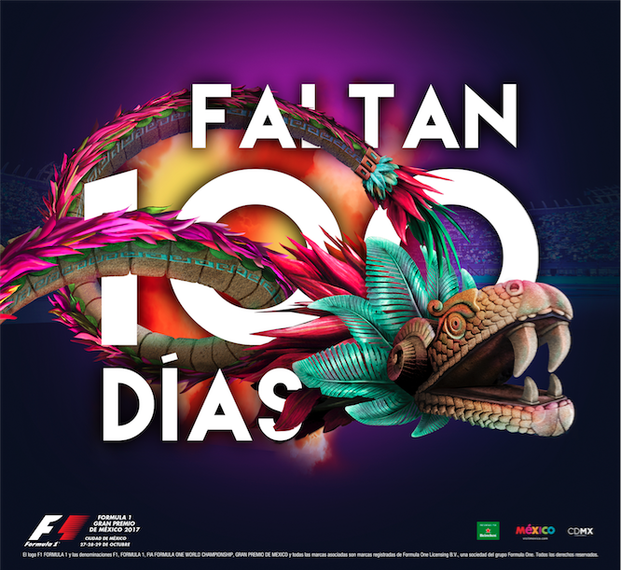

In that order, arrangements to give a unique F1®ESTA to all fans this year have begun, which besides of the gastronomic and entertainment offer of previous years, it also includes have a new supporting race: Porsche Mobil 1 Supercup – a competition full of tradition which will be carried out in the American Continent.

Likewise, that weekend will ensure to become the best and the most expected of all 2017, since that Saturday prior to the Grand Prix coincides with the return to Mexico of the former Beatle, Paul McCartney, who will present his One on One Tour at Azteca Stadium on October 28.

During last two years and its return to Aztec lands, FORMULA 1 GRAN PREMIO DE MÉXICOTM has not only turned into one of the best Grand Prix in the world, but also into one with the biggest number of fans received, with over 330 thousand of visitors at Autódromo de los Hermanos Rodríguez throughout that weekend. Becoming that way in the second Grand Prix with the biggest number of visitors, only behind Silverstone’s, in Great Britain.

Do not miss the experience that has amazed everyone! Be a part of the color, adrenaline, fun and speed of the best F1®ESTA in the world. Are you ready?

Tickets are on sale through the Ticketmaster system, on www.ticketmaster.com.mx, authorized Ticketmaster Centers, calling 5325 9000 or ticket office number 7 placed in Palacio de los Deportes.

We also offer a wide variety of corporate products for companies and business partners. You may ask for more information, calling 2122-3009 and 2122-1505 or writing to VentasVip@cie.com.mx.

WWW.MEXICOGP.MX

#MexicoGP #F1ESTA

For more information, follow us on:

@Mexicogp | Mexicogp
MexicoGP | MexicoGP

Press contacts:

CIE  Francisco Velázquez  Press Manager  T. 5201-9089  fvelazquezc@cie.com.mx | MAKKEN  María Torres Farber  Account Director  T. (55) 41600 800 / 900  maria.torres@makken.com.mx

About FORMULA 1 GRAN PREMIO DE MÉXICO™:
The highest category in motor racing has returned to Mexico, after 23 years of absence, pioneer of the greatest sport events in our country. With a term from 2015 to 2019 the renewed Autódromo Hermanos Rodríguez is the perfect stage for the return of the F1ESTA to our country, with a highest world-class level track.
On its first two editions (2015 and 2016), over 375 thousand people attending the race, turned into the second with the biggest number of spectators around the world (after Great Britain).
Until now, FORMULA 1 GRAN PREMIO DE MÉXICO™ has generated over 22 thousand jobs, economic revenue of 1,119 MDD (24,841 million of pesos).
One more year, Mexico will create a world-class position during racing that will take place from October 27th, to October 29th, after having been awarded as the Best Event of the Year by the maximum authorities in world professional motor racing FIA and FOM, during its first two editions.
For further information about FORMULA 1 GRAN PREMIO DE MÉXICO™ go: http://www.mexicogp.mx/

About Formula 1®:
Formula 1® is the most prestigious motor racing competition in the world that has taken the position of the most popular annual sport competition in the planet: In 2016 the championship was witnessed by 400 million of viewers only from over 200 places.
With a long history of glory and racing written since 1950, Formula 1® has been bastion for great drivers, as well as for iconic teams that had led motor racing to being part of collective memory in millions of fans all around the world.
In 2016 FIA Formula One World Championship™ took place from March to November, including 21 races in 21 countries of the five continents. Formula One World Championship Limited is part of Formula 1® and owns the exclusive commercial rights to FIA Formula One World Championship™.
Formula 1® has being raced in Mexico for 17 times, being editions 2015 and 2016 recognized as “The best Grand Prix of the world”. For further information about Formula 1® go to: www.formula1.com

About CIE:
Corporación Interamericana de Entretenimiento, S.A. de C. V. www.cie.com.mx
We are the market leader in outdoor entertainment in Mexico, Colombia and Central America and one of the major players in the entertainment industry in Latin America and across the globe.
CIE offers a variety of world-class entertainment options including concerts, theater productions, and sports and family and cultural events, among others, to meet our market segments’ needs for recreation and entertainment through its unique vertical integration model that provides the only access available to an extensive network of entertainment centers, advertisers, including the main advertising investors in our markets, and partnerships and strategic alliances with experienced global partners.
We operate an amusement and water park in Bogota, Colombia, and manage Centro Banamex in Mexico City, one of the largest convention and exhibition facilities across the globe. We are recognized as the foremost producer and organizer of special and corporate events in Mexico, and we operate one of the most professional contact centers in the Mexican market.
CIE is a public company whose shares and debt securities are listed on the Mexican Stock Exchange.

