Mexico City, June 29, 2017.

FORMULA 1 GRAN PREMIO DE MÉXICOTM and Paul McCartney meet again after 55 years.

In those days when the music of the British band The Beatles was revolutionizing the world, at the end of 1962, Mexico was getting ready to receive the first visit of Formula 1® with a World Championship non-scoring race.
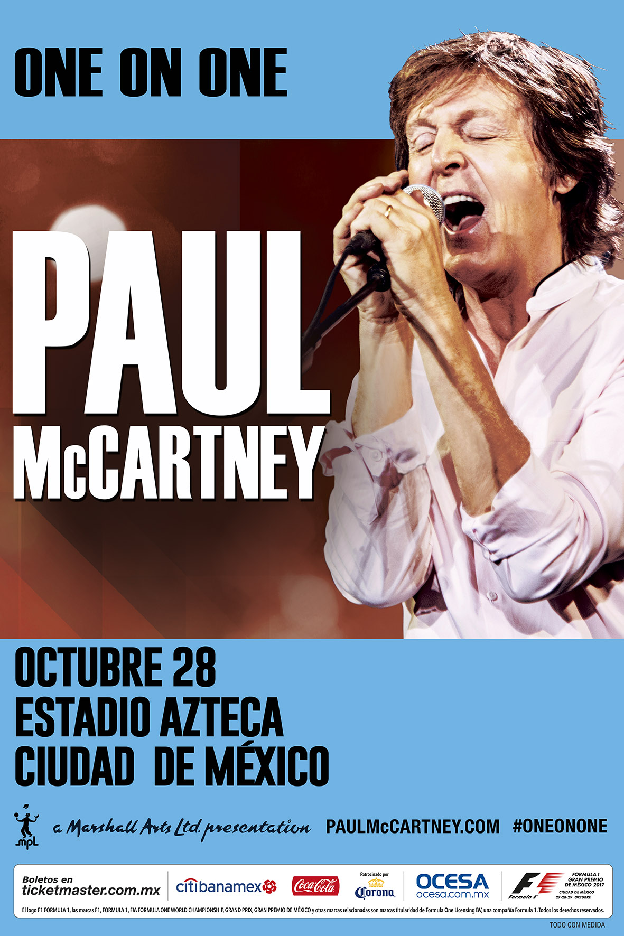
Just 55 years later, the highest category has already scheduled another edition of FORMULA 1 GRAN PREMIO DE MÉXICOTM from next October 27 to 29, at the same time Paul McCartney, bass player, of the legendary quartet from Liverpool, will offer a concert on the night of October 28, at the stadium Azteca.
McCartney, together with John Lennon, George Harrison and Ringo Starr, transformed music world during the 60’s last century, and from their first hit, Love do, to the Let it album launched in 1970.
During that same decade, the Magdalena Mixhuca circuit was venue of eight FORMULA 1 GRAN PREMIO DE MÉXICOTM editions. Among the participating drivers during the first stage we have the highlighted Jim Clark from Scotland, winner in 1963 and 1965; that got on the podium in four occasions, among which there is his victory in 1968, and the Scottish Jackie Stewart, winner in 1969; besides the Mexican idol, Pedro Rodríguez.
In April 1970, McCartney separated from The Beatles, while in October during that year Formula 1® was closing the first season of FORMULA 1 GRAN PREMIO DE MÉXICOTM with the Austrian Jochen Rindt as the winner.
The second season of F1® racing in Mexico took place between 1986 and 1992, where drivers of the level of Ayrton Senna, Alain Prost, Nelson Piquet, Gerhard Berger, Michael Schumacher and Nigel Mansell, raced on the Autódromo Hermanos Rodríguez’ track, having this last one as the winner on the closing test for that season.
The following year, in November 1993, Paul McCartney came to our country for the first time with The Beatles’ music under his arm to give a concert on a particular scenery: the Autódromo Hermanos Rodríguez’ forum, nowadays, called Foro Sol.
McCartney, winner of 21 Premios Grammy, will have his fifth visit to México. After his two concerts in 1993, Paul came in November 2002 with three concerts at Palacio de los Deportes; in 2010 he played two times in Foro Sol; and during May 2012 he offered several shows in Guadalajara, in the Stadium Azteca and in Mexico City’s Zócalo, where he gathered over 200 thousand people.
During the third season, the FORMULA 1 GRAN PREMIO DE MÉXICOTM has already been distinguished as Best Race of the Year in 2015 and 2016, and for 2017 it seems to win that test where it is among the favorites for drivers like Lewis Hamilton, Sebastian Vettel, Daniel Ricciardo, Kimi Räikkönen, Felipe Massa and the driver from Guadalajara, Sergio Pérez.
Do not miss living twice the unforgettable experience of witnessing the FORMULA 1 GRAN PREMIO DE MÉXICOTM from October 27 to 29 at the Autódromo Hermanos Rodríguez; and enjoying the legendary music of Paul McCartney, on the night of October 28 in the Stadium Azteca, to celebrate the 55 years of F1 arising in our country and the Beatlemania resurgent.
Get your tickets for both experiences at the Ticketmaster System, or calling 53259000.

WWW.MEXICOGP.MX

#MexicoGP #F1ESTA

For moer information, follow us on our social media:

@Mexicogp | Mexicogp
MexicoGP | MexicoGP

Press contacts:

CIE  Francisco Velázquez  Press Manager  T. 5201-9089  fvelazquezc@cie.com.mx | MAKKEN  María Torres Farber  Account Manager  T. (55) 41600 800 / 900  maria.torres@makken.com.mx

About FORMULA 1 GRAN PREMIO DE MÉXICO™:
The highest category in motor racing has returned to Mexico, after 23 years of absence, pioneer of the greatest sport events in our country. With a term from 2015 to 2019 the renewed Autódromo Hermanos Rodríguez is the perfect stage for the return of the F1ESTA to our country, with a highest world-class level track.
On its first two editions (2015 and 2016), over 375 thousand people attending the race, turned into the second with the biggest number of spectators around the world (after Great Britain).
Until now, FORMULA 1 GRAN PREMIO DE MÉXICO™ has generated over 22 thousand jobs, economic revenue of 1,119 MDD (24,841 million of pesos).
One more year, Mexico will create a world-class position during racing that will take place from October 27th, to October 29th, after having been awarded as the Best Event of the Year by the maximum authorities in world professional motor racing FIA and FOM, during its first two editions.
For further information about FORMULA 1 GRAN PREMIO DE MÉXICO™ go: http://www.mexicogp.mx/

About Formula 1®:
Formula 1® is the most prestigious motor racing competition in the world that has taken the position of the most popular annual sport competition in the planet: In 2016 the championship was witnessed by 400 million of viewers only from over 200 places.
With a long history of glory and racing written since 1950, Formula 1® has been bastion for great drivers, as well as for iconic teams that had led motor racing to being part of collective memory in millions of fans all around the world.
In 2016 FIA Formula One World Championship™ took place from March to November, including 21 races in 21 countries of the five continents. Formula One World Championship Limited is part of Formula 1® and owns the exclusive commercial rights to FIA Formula One World Championship™.
Formula 1® has being raced in Mexico for 17 times, being editions 2015 and 2016 recognized as “The best Grand Prix of the world”. For further information about Formula 1® go to: : www.formula1.com

About CIE:
Corporación Interamericana de Entretenimiento, S.A. de C. V. www.cie.com.mx
We are the market leader in outdoor entertainment in Mexico, Colombia and Central America and one of the major players in the entertainment industry in Latin America and across the globe.
CIE offers a variety of world-class entertainment options including concerts, theater productions, and sports and family and cultural events, among others, to meet our market segments’ needs for recreation and entertainment through its unique vertical integration model that provides the only access available to an extensive network of entertainment centers, advertisers, including the main advertising investors in our markets, and partnerships and strategic alliances with experienced global partners.
We operate an amusement and water park in Bogota, Colombia, and manage Centro Banamex in Mexico City, one of the largest convention and exhibition facilities across the globe. We are recognized as the foremost producer and organizer of special and corporate events in Mexico, and we operate one of the most professional contact centers in the Mexican market.
CIE is a public company whose shares and debt securities are listed on the Mexican Stock Exchange.

