Mexico City, October 25, 2016.

How to read your FORMULA 1 GRAN PREMIO DE MEXICO 2016™ ticket?

If you are one of the lucky ones to secure their entrance to the FORMULA 1 GRAN PREMIO DE MEXICO 2016™, we teach you the right way to read your ticket to access the Autodromo Hermanos Rodriguez in a fast and efficient way.

· On the back you will find the kind of ticket and the section/hall – including corresponding row and seat. Please take in consideration there are sections, such as General without numbered seats.
· A little further down you will find the grandstand number and the access door. Remember you shall access through the door indicated on your ticket only. Which is why for your convenience, it was enabled a shuttle that will stop at different doors throughout the Autodromo Hermanos Rodriguez.
· In the middle part of the ticket you will find your corresponding zone (divided by color). A little further down there are specified the day, date and hour for each ticket.

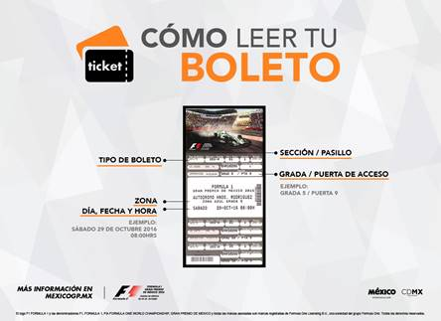

Remember that the only official sale points are Ticketmaster System (www.ticketmaster.com.mx, Ticketmaster Centers in the Republic or calling 5325-9000), the ticket window 7 at Palacio de los Deportes, Grupo Cie and Gupo Mundomex corporative sales team.
Are you ready t olive the best F1ESTA of the year with the FORMULA 1 GRAN PREMIO DE MEXICO 2016™?

To download high definition pictures, click on the following link:
https://we.tl/XcRpWx11Xp
-or-

www.mexicogp.mx
Facebook: mexicogp
Instagram/Twitter: @mexicogp
#MexicoGP #F1ESTA #F1EBRE

Contact:
Francisco Velázquez  fvelazquezc@cie.com.mx  (52 55) 52019089  CIE | Manuel Orvañanos  manuel@bandofinsiders.com  (52 55) 63866686  Band of Insiders

About CIE
Corporación Interamericana de Entretenimiento, S.A.B de C. V.
www.cie.com.mx
We are the market leader in outdoor entertainment in Mexico, Colombia and Central America and one of the major players in the entertainment industry in Latin America and across the globe.
CIE offers a variety of world-class entertainment options including concerts, theater productions, and sports and family and cultural events, among others, to meet our market segments’ needs for recreation and entertainment through its unique
vertical integration model that provides the only access available to an extensive network of entertainment centers, advertisers, including the main advertising investors in our markets, and partnerships and strategic alliances with experienced global partners.
We operate an amusement and water park in Bogota, Colombia, and manage Centro Banamex in Mexico City, one of the largest convention and exhibition facilities across the globe. We are recognized as the foremost producer and organizer of special and corporate events in Mexico, and we operate one of the most professional contact centers in the Mexican market.
CIE is a public company whose shares and debt securities are listed on the Mexican Stock Exchange.

