Mexico City, March 10th, 2016

SECRETARIAT OF FEDERAL TOURISM AND CORPORACION INTERAMERICANA DE ENTRETENIMIENTO (CIE) REVEALED ECONOMIC PERFORMANCE FROM FORMULA 1 GRAN PREMIO DE MEXICO 2015.
· Enrique de la Madrid, Secretary of Tourism, along with Alejandro Soberon, Chairman and Chief Executive of CIE, presented the results of the economic impact and the global exposure of FORMULA 1 GRAN PREMIO DE MEXICO 2015.
Last Thursday, at the National Marine Navy Casino, Enrique de la Madrid, Secretariat of Tourism, along with Alejandro Soberon, CIE’s Chairman and Chief Executive, and Eduardo Sanchez Hernandez, spokesman of the Government of the Mexican Republic, revealed to mass media the economic and media impact of FORMULA 1 GRAN PREMIO DE MEXICO 2015.
After the great success behind the return of Formula 1 to our country, promoter of FORMULA 1 GRAN PREMIO DE MEXICO, CIE hired the international enterprises, AECOM AND FORMULA MONEY to analyze results and benefits that this event represented for Mexico in 2015.
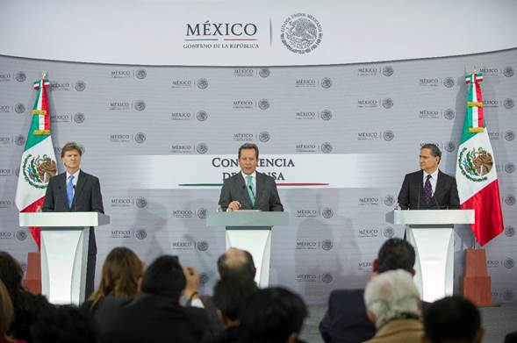

Analyses produced the following results:
- With a total of 336,174 spectators, the Gran Premio de Mexico in 2015 became the second most attended race of all championship, just below the most ancient race, The Silverstone Grand Prix.
- FORMULA 1 GRAN PREMIO DE MEXICO 2015 contributed to the country’s economy with $3,944 million of pesos, $4,705 million of pesos, for the media exposure value which combine for a total $8,649.00 million of pesos.
- On the other hand, only in 2015 the Autodromo Hermanos Rodriguez renovation produced $4,112 million of pesos adicionales, lo que nos da como resultado una derrama económica total para México $12,761 millones de pesos.
- In 2015 over 13,500 jobs were created in the region arose from the event, which produced a profit of over $1,400 million of pesos in wages.
- Hotel occupancy produced a hotel room sale increment of for $321 million of pesos during the week of the event.
- Foreign visitors spent about $295 million of pesos in our country during their stay, this without considering the event ticket costs and lodging.
- The race carried out in our country was broadcasted in 185 countries by 119 TV stations and received 1,550 hours of global coverage.
- The brand “Mexico” displayed on the track became the second most TV exposed brand in all championship, which represented a total of $767 millions de pesos to our country in media exposure.
- Over 11,000 press notes about FORMULA 1 GRAN PREMIO DE MEXICO 2015 were released during the week of the event, impacting almost 2 thousand million of people around the world.
- In social networks over 2,318 million of views were generated, reaching over 87 million of users globally. Hashtags #GPMexico and #F1 became global trend resulting in the interaction of 80% in the international market and 20% in the national territory. Users shared over 350 thousand of photos throughout the 3-day event.
“The most important asset we have in the touristic area is the Mexican people, quality and our incomparable warmth. This is shown day by day, also during this kind of world-class events such as Formula 1”. Said Enrique de la Madrid, Secretary of Tourism.
“We are so proud to announce the results. Bringing Formula 1 back to Mexico has given us a lot of satisfaction, this first edition has been recognized as the Best Event of 2015 season by FIA and FOM, also this year CIE was named “Best Promoter” of the continent by FIA Americas. We feel really pleased to verify today that all these pleasures come with results that really benefit our country, not only on its reputation, but also economically; this is undoubtedly the result of a great team work from thousands of people and from the correct cooperation between the government and private industry”. Said Alejandro Soberon, CIE’s Chief Executive and CEO. “The challenge to face for the 4 following years is huge, but we are now working really hard to keep on bringing positive results for Mexico”, finished.
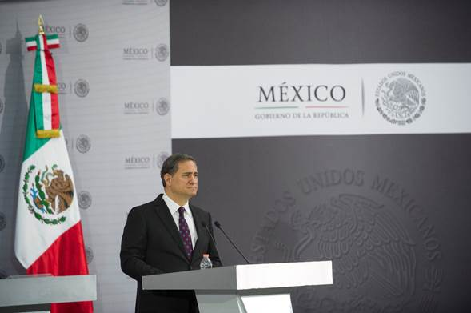
www.mexicogp.mx
Facebook: mexicogp
Instagram/Twitter: @mexicogp
#MexicoGP #F1ESTA
Press contacts
Francisco Velazquez Manuel Orvañanos
fvelazquezc@cie.com.mx Manuel@bandofinsiders.com
(52 55) 52019089 (52 55) 63.86.66.86
CIE Band of Insiders

About CIE
Corporacion Interamericana de Entretenimiento, S.A.B de C. V.
We are the market leader in outdoors entertainment in Mexico, Colombia and Central America and one of the most outstanding participants in Latin America and worldwide entertainment industry.
Through a unique vertical integration model, and the only Access to an important network of entertainment centers, a base of advertisers formed by the main advertising investors in our market, as well as the alliances and strategic partnerships that we have established with experienced participants in global industry; we offer different world-class entertainment options, which include concerts, theater productions, sports, family and cultural events, among others to satisfy leisure and recreation needs for our audiences.
We operate an amusement and an aquatic park in Bogota, Colombia. Also, we commercialize the Banamex Center in Mexico City, one of the biggest and most important exhibition and convention venues internationally. In addition we are recognized as the foremost producer and organizer of special and corporative events in Mexico, and for operating one of the most professional contact centers recognized in the Mexican Market.
CIE is a public Company whose shares and debit securities are listed in the Mexican Stock Exchange.
www.cie.com.mx
About the companies that conducted the study:
AECOM
American company with presence in 150 countries dedicated to building, financing and operating infrastructure assets for business and government industry. Experts in consulting services, strategies focused on communities, nations and infrastructure assets. With annual sale profits of over US $18 billion, listed on the Fortune 500 group.
http://www.aecom.com/
FORMULA MONEY
Emission published by CNC Group, with all information regarding to Formula 1, its economical and media impact. CNC has 11 offices around the world.
http://www.formulamoney.com/

