Mexico City, October 30,2015

Nearly 90 thousand people witnessed the return of FORMULA 1® to Mexico, in the Autodromo Hermanos Rodriguez after a 23-year absence.

Mexico fervently received motorsport world top category. After 23 years, our country shows to be ready to receive a world-class event such as FORMULA 1.

With the access to 89,365 fans on the first day, the Autodromo Hermanos Rodriguez was the ideal stage for the practice sessions. All the action began at 8 o’clock in the morning on the different access gates of the facility, there was a lot of expectation and anxiety to watch all the teams’ cars running on the new track.

Fans began to set the mood. Both, adults and children dressed in distinctive colors from their favorite teams to welcome them and show their support.

At 10 o’clock in the morning took place the first practice session where Max Verstappen, from Scudery Toro Rosso, set the best time with a 1:25.990-seconds laps; Daniil Kvyat from Scudery Infiniti Red Bull Racing was the second fastest, only three tenth of a second behind, then finished both Kimi Räikkönen and Sebastian Vettel’s cars. After a tiny overcome setback, Sergio Perez finished in the 9th position with a time set of 1:27.581.
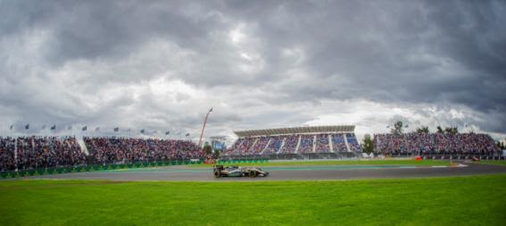

On the second practice session, fans witnessed how Max Verstappen abandoned the race after losing control of the car and moving out from the stadium zone on curve 17. Valtteri Bottas also had a mishap on curve one, but he was still capable to go back to the track after a pit stop. During the session, Rosberg set his best time of (1:21.531) followed by Daniil Kvyat and Daniel Ricciardo. The Mexican Checo Perez reached place 15th with a time set of 1:23.597.

After practice sessions results on this first day, it became clear that the Autodromo Hermanos Rodriguez fast can easily turn into the fastest track in the world.

To complement the experience, the Autodromo relived its long history when Masters Historic Racing cars came out to the track, together with the Grid Girls. This practice session finished with the British, Aaron Scott’s March 761 on the first position, whose exhibition contrasted with Formula 4’s modernity and technology where the Australian, Luis Leeds, set the best time for team RAM2.

The first day of the FORMULA 1 GRAN PREMIO DE MEXICO 2015® mean tan unforgettable experience for all the spectators, the food, the flags, the caps and the festive atmosphere arose early within the different into which the Autodromo Hermanos Rodriguez was divided.

The return of FORMULA 1® to our country captured the attention of different celebrities and Mexican socialites such as Oswaldo Benavides, Carlos Slim, Juan Antonio Perez Simon, Ernesto Torres Cantu, Eduardo Henkel, Carlos Peralta and even His Majesty, Juan Carlos I of Spain.

Everyone left the Autodromo facilities with the best impression, waiting for the great momento on Sunday, when the Gran Premio de Mexico winner is crowned at the Podium spectacularly installed in the Foro Sol.

To all the fans, please remember the Autodromo Hermanos Rodriguez does not have parking lot service, so we recommend taking public transport.

¡Undoubtedly FORMULA 1® will come to Mexico to stay!

Download photos of the first day at the FORMULA 1 GRAN PREMIO DE MEXICO 2015® on our Media Center entering the following link:
www.ahr.mx/f1/mediacenter/

Visit and Enjoy Mexico with the FORMULA 1 GRAN PREMIO DE MEXICO 2015®.
In case of further doubts please call the toll-free number 01 800 777 77 F1

www.ahr.mx
Facebook: Autódromo Hnos Rodríguez
Instagram/Twitter: @autodromohr
#MexicoGP

Contacts
Francisco Velázquez  fvelazquezc@cie.com.mx  (52 55) 52019089  CIE | Manuel Orvañanos  manuel@bandofinsiders.com,  (52 55) 63866686  Band of Insiders

About CIE
Corporacion Interamericana de Entretenimiento, S.A.B de C. V.

www.cie.com.mx
We are the market leader in outdoors entertainment in Mexico, Colombia and Central America and one of the most outstanding participants in Latin America and worldwide entertainment industry.
Through a unique vertical integration model, and the only Access to an important network of entertainment centers, a base of advertisers formed by the main advertising investors in our market, as well as the alliances and strategic partnerships that we have established with experienced participants in global industry; we offer different world-class entertainment options, which include concerts, theater productions, sports, family and cultural events, among others to satisfy leisure and recreation needs for our audiences.
We operate an amusement and an aquatic park in Bogota, Colombia. Also, we commercialize the Banamex Center in Mexico City, one of the biggest and most important exhibition and convention venues internationally. In addition we are recognized as the foremost producer and organizer of special and corporative events in Mexico, and for operating one of the most professional contact centers recognized in the Mexican Market.
CIE is a public Company whose shares and debit securities are listed in the Mexican Stock Exchange.

