Mexico City, October 20,2015

WHITING’S LAST VISIT TO THE AUTODROMO HERMANOS RODRIGUEZ CONCLUDED SUCCESSFULLY
Charlie Whiting, FORMULA 1® Race and Safety Director, predicts a spectacular race.
After 15 months of remodeling and adaptations hard work, the Autodromo Hermanos Rodriguez is now ready to receive the FORMULA 1® after 23 years of absence.
FORMULA 1® Race and Safety Director, Charlie Whiting, carried out a last inspection visit to the 4.305 kilometers of layout. “I acknowledge the great work that has been made on all the Autodromo Hermanos Rodriguez facilities in just over a year, I am pretty sure the FORMULA 1 GRAN PREMIO DE MEXICO 2015® is going to be a spectacular race”, he assured.

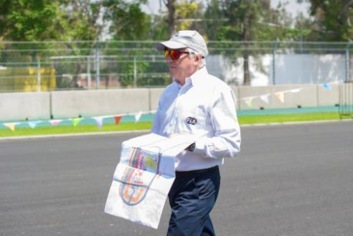

Whiting walked through the renewed layout accompanied by CIE authorities and FIA Mexico, who also claimed to be ready to receive over 300 thousand of spectators that will attend the place during the weekend of the racing.
“In just one week we will be receiving FORMULA 1® celebrities and teams, we feel really pleased with the work that has been made during the remodeling period. The Autodromo Hermanos Rodriguez will be without a doubt on a par with all those tracks involved on the championship”, said, Federico Gonzalez Compean, FORMULA 1 GRAN PREMIO DE MEXICO General Director.

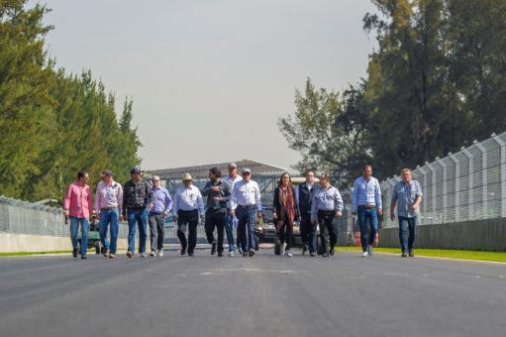

Nowadays the last details of the circuit are being finished, the kerbs (curbs) and the run-offs areas are being painted to finally place all FOM (Formula One Management) publicity.

There are still available tickets for the FORMULA 1 GRAN PREMIO DE MEXICO 2015 and preliminary races. Stakeholders please consult availability on the Ticketmaster system, at their website www.ticketmaster.com.mx, at any of the Ticketmaster Mexico Centers, going to ticket window number 7 of the Palacio de los Deportes in Mexico City, calling 5325-9000, or at the official Autodromo Hermanos Rodriguez website www.ahr.mx.

Visit and Enjoy Mexico with the FORMULA 1 GRAN PREMIO DE MEXICO 2015®.
www.ahr.mx
Facebook: Autodromo Hnos Rodriguez
Instagram/Twitter: @autodromohr
#MexicoGP

Contacts
Francisco Velazquez  fvelazquezc@cie.com.mx  (52 55) 52019089  CIE | Manuel Orvañanos  manuel@bandofinsiders.com  (52 55) 63866686  Band of Insiders

About CIE
Corporacion Interamericana de Entretenimiento, S.A.B de C. V.

www.cie.com.mx
We are the market leader in outdoors entertainment in Mexico, Colombia and Central America and one of the most outstanding participants in Latin America and worldwide entertainment industry.
Through a unique vertical integration model, and the only Access to an important network of entertainment centers, a base of advertisers formed by the main advertising investors in our market, as well as the alliances and strategic partnerships that we have established with experienced participants in global industry; we offer different world-class entertainment options, which include concerts, theater productions, sports, family and cultural events, among others to satisfy leisure and recreation needs for our audiences.
We operate an amusement and an aquatic park in Bogota, Colombia. Also, we commercialize the Banamex Center in Mexico City, one of the biggest and most important exhibition and convention venues internationally. In addition we are recognized as the foremost producer and organizer of special and corporative events in Mexico, and for operating one of the most professional contact centers recognized in the Mexican Market.
CIE is a public Company whose shares and debit securities are listed in the Mexican Stock Exchange.

