Mexico City, August 2, 2015

The impressive event of Scuderia Ferrari Street Demo by Telcel - Infinitum in Paseo de la Reforma

Over 80 thousand people, especially families and motorsport fans, gathered on Sunday, August 2, to witness the Scuderia Ferrari Street Demo by Telcel - Infinitum, a demonstration of the Mexican drivers Gutierrez and Ricardo Perez de Lara, who drove Ferrari iconic cars on the avenue Paseo de la Reforma in Mexico City, as a preliminary event for what is about to come in the FORMULA 1 GRAN PREMIO DE MEXICO 2015®.

After the Ministry of Tourism, Claudia Ruiz Massieu gave the starting signal to the participants drivers, and said this sport exhibition engages society, as a simple of what will come with the FORMULA 1 GRAN PREMIO DE MEXICO 2015®.to be held next November at the Autodromo Hermanos Rodriguez in this city, a world-class sports experience, that will also allow the use of this unique platform to project Mexico as world-class destination and promote diversification of touristic destinations and cultural, gastronomic, historical and natural attractions in our country.

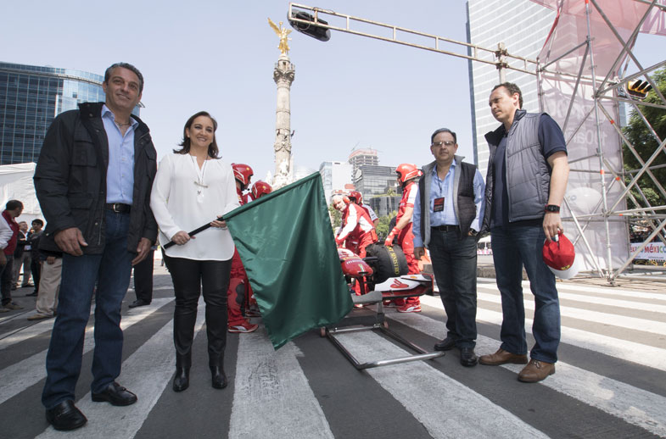

The F60 driven by Esteban Gutierrez and the 458 Challenge EVO driven by Ricardo Perez de Lara rolled on the avenue Paseo de la Reforma, from the “Palma” roundabout to the Diana Cazadora fountain. Drivers first took a tour showing the great power in each of their machines to exhibit a series of maneuvers that thrill all the attendants.

A thousand of fans attended the exhibition dressed in red to show their support to the Mexican drivers and posted their best pictures on the social networks using the Hash Tag #SFStreetDemoMX. They witnessed the maneuvers of Esteban and Ricardo, in the vicinity of Diana Cazadora and at the Palma roundabout, where the powerful sound of the Ferrari engines was heard. The demonstration finished when Esteban took the pedestal of the Angel of Independence to greet the audience and taking another lap aboard the convertible Ferrari, carrying proudly the Mexican flag.

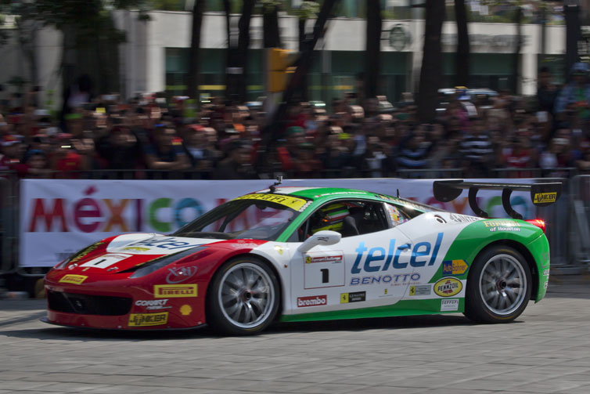 | 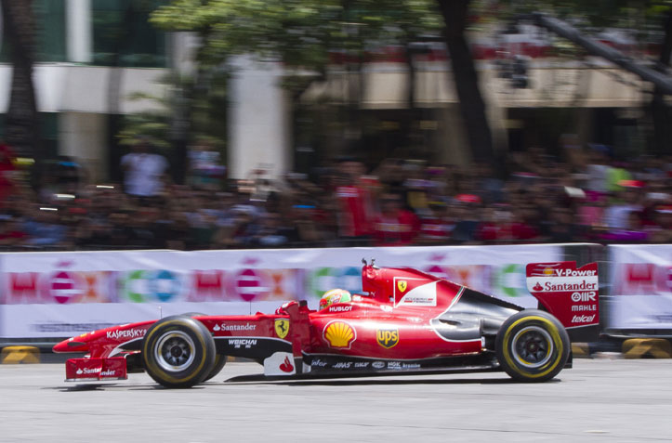

‘I am excited to be in Mexico witnessing the support and love from the people. Driving the F60 on one of the most emblematic avenues of the country was an incredible experience. I hope that all who attended the event have enjoyed as much as me’, said Esteban Gutierrez.

‘I cannot describe how exciting it was to drive my rod on Reforma; Mexican fans are certainly the best. I can’t wait to see what will come with GRAN PREMIO, it is going to be a historical and unforgettable event’, said Ricardo Perez de Lara.

Prior to the appearance of Esteban and Ricardo, Reforma was adorned with Ferrari Show Club, a parade with the most representative classic and modern models, like the 308 GTS, the 355 Berlinetta, the 458 Italia, the 458 Speciale, the 458 Spider, the 550 Barchetta and the California T, among others. Moreover the exhibition of the Scuderia Telmex cars.

Scuderia Ferrari Street Demo by Telcel – Infinitum 2015 was conducted with the support of the Ministry of Tourism of the Government of the Republic, with the Council of Tourism Promotion in Mexico, Mexico City Government through the Institute of Sport, Telcel, Claro, Infinitum, Kaspersky Lab and Hublot.

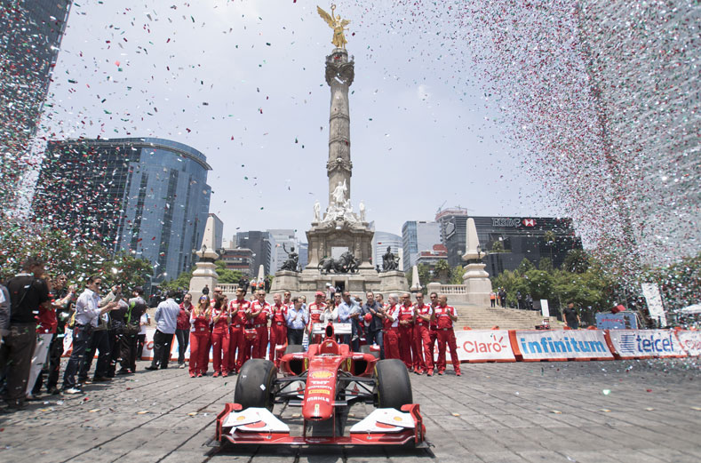 | 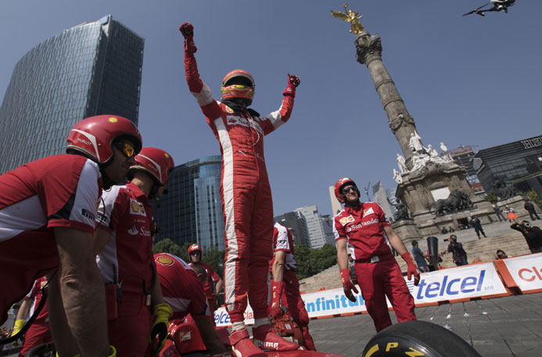

#SFStreetDemoMX

To download high-definition pictures and videos of the event click on:
http://sfstreetdemomx.com/index.php/login

Visit and enjoy Mexico with the FORMULA 1 GRAN PREMIO DE MEXICO 2015®.
www.ahr.com.mx
Facebook: Autodromo Hermanos Rodriguez
Instagram/Twitter: @autodromohr
#MexicoGP

Contacts
Francisco Velazquez  fvelazquezc@cie.com.mx  (52 55) 52019089  CIE | Manuel Orvañanos  manuel@bandofinsiders.com  (52 55) 63866686  Band of Insiders



